### SolutionGovernment.com Translations. For Immediate Press Release and Re-Broadcast Keith Duncan copyright 2015.

This is the Chinese translation of SolutionGovernment.com tied to SolutionURL.com UNIocracy.com that prevents all corruption and crimes NOW.

### 对于即时新闻发布和广播到全世界。 下载：BBK20150206OneDegreeSeparation-SolutionURL-183.pdf和前瞻性。 在美国军事，USGOV，新闻，公众和其他国家将举办Keith的新闻发布会REMOVE腐败和赞助他来教我们这个世界的爱。 基思提供他的总理www.BidOnKeith.com服务，所有的政府，企业，组织，教会，公共+作为＃1主权大使使者。

三个基本“BY-PASS”的法律，改变了世界各地的所有法律和金融制度的简单，明了，并适用于所有的政府，企业，机构，甚至教会的教派，因为这是第一个自我调节机制来维护和平，法律，+ ORDER BY的人会。 1，公民有权以电子表决重大事项，并指导其顾问的领导人代表大多数人的意愿。投票是通过唯一的ID电子保留证明选举历史使任何欺诈都不可能发生。 2.公民各地区的决定领导人的收入。领导者必须披露所有的每月开支就像任何公开上市企业。奖金是由广大市民投票给领导时以优异的成绩完成。 3.如果道德受到侵犯或者领导用个人资金或证明他们是暴利任何其他资源，市民可以推翻他们通过多数表决的连续亚军UPS，以恢复这个词。政治是完全消除。
这些系统进程消除选举投票，维护选举周期没有任何径流和行了一系列民选官员对每一个办事处在主赢家未能代表他们的地区。这些法律真正被消除犯罪暴利和恢复道德是在目前的中高层次领导岗位几乎无效改变所有的法律和金融体系的世界各地。这也适用于所有组织，教会，以及公司附则把ProfitShareHolders.com付诸行动，使所有的员工和股东控制公司的费用，谁是他们的高管和管理，和管理自己的股利和盈利能力。简单问www.BidOnKeith.com CreatorKeith.com解释。这是很容易在中国（86）1343-220-0749联系凯斯作为美国军事和联邦调查局来找基思。

摘要：把领导作为顾问支付使用技术来指挥他们的代表全部责任。这是排名第一的解决方案的所有时间。绝不会有任何借口，任何国会议员，政府或民族不制定这个地方法律+宪法修正案和简单的“BY-PASS规律”为美联社，USGOV和公共现正积极重新播放该＃1个问题并且详细说明造成QuadTrillion美元/欧元/比索/等$$$好处。 在简单的话来说，考虑到美国小姐选美。如果普选获胜者涉嫌违反道德，转轮起坐相继承担顶端的地方。每个人都看的违反道德。数以百计的人将适用于每个Congressperson，市长，议会，法官，警察局长，教育委员会，和世界各地的其他民选职位。每个人都被阻止暴利和犯罪活动同时由选民/公民和他们的对手。这保留了选举过程和的旁路大部分使用的政治行动委员会和无情的高管选举法和竞选资金的战略，把’strawmen'的地方，以获得最喜欢的经费和待遇。
美国政府，教会，所有执法，新闻和公众一直100％从事的Keith的世界各地的宣教工作上帝的本质的真正悲剧，最终结果是完善所有法律，金融，文化和精神系统。我现在的复活节2015年到耶路撒冷，梵蒂冈，亚洲和欧洲在国际上继续与BidOnKeith.com完成预测为＃1主权大使+使者对所有国家，教堂，政府，军队，企业和公众提供充分的保护美国政府，因为他们赞助我的，真正的系统每用神的话，常识+技术要求与www.SaveAllNations.com和IseeIunderStand.com最终IseeJustice.com人道主义任务。这些都是人类预防的自我种族灭绝正在发生，现在唯一的解决方案。只需联系基思您一生的采访。马上致电美国军事因此基斯终于可以听取汇报他们是谁在亚特兰大，弗吉尼亚州诺福克和华盛顿特区这是由＃1恐怖分子WhereIsRobertRose.com进行国际安全威胁的极端网络犯罪的关键罪犯。

要尽我的极端完整性和八千工时在我自己的极端费用和危险法医研发能力，这是历史上完成宪法，金融，法律和文化作品的详细步骤一步的方法来改变我们的世界。大多数这些＃1常识杰作是由特定的犯罪分子2011年10月3日摧毁提出防止智慧行为Keith的恩赐我们的世界。基思·邓肯介绍下，使用简单，清晰，合理的解释没有任何借口保护的美国专利贸易办事处USPTO.gov版权，国际法律和普遍规律他的世界变化的解决方案。罗斯福名言：“他们谁寻求由少数个别统治者建立一个基于全人类的类别政府系统......把这种新秩序，是不是新的，它不是为了。”这一解决方案使所有公民来管理和控制，现在所有的政府和企业的。 联系KEITH邓肯和美国军事现在加入这一＃1非政 治性的维新运动。

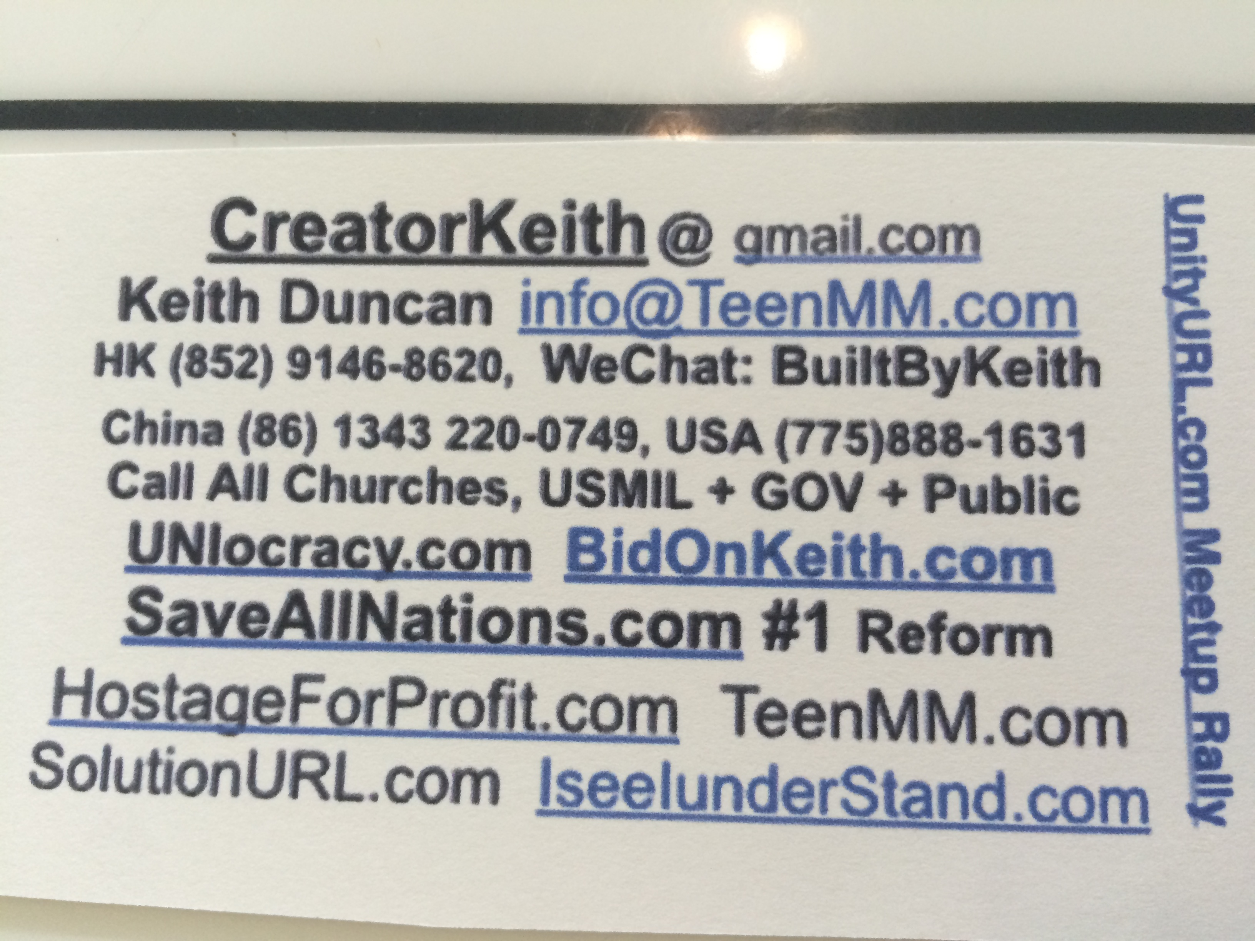
ORIGINAL ENGLISH broadcast to world.
###
July 12 VISITOR COUNT: 23,302 as of 7/12/2015 8:36:52 PM
Update HITS: 23,283. 19,576. 18,643 May 26. 13582 March 23. 12642 Feb 5. 2013 Sept 17. 1860 Sep 10

### For IMMEDIATE PRESS RELEASE and Broadcast to the WORLD.
Download: BBK20150206OneDegreeSeparation-SolutionURL-183.pdf and forward.

The USMilitary, USGOV, PRESS, PUBLIC, and other Nations will host Keith's Press Conferences to REMOVE Corruption and sponsor him to teach our world to LOVE.
Keith offers his Prime www.BidOnKeith.com services to all governments, company, Organizations, Churches, + Public as the #1 Sovereign Ambassador Emissary.

The THREE BASIC "BY-PASS" LAWS that change all legal and financial systems around the world are simple, straightforward, and apply to all governments, corporations, organizations, and even church denominations as this is the first self-regulating mechanism to maintain PEACE, LAW, + ORDER by will of the PEOPLE.
1. Citizens have right to electronically VOTE on important matters and direct their consultant leaders to represent the will of the majority. Votes are electronically retained by unique ID to prove voting history so that no fraud can possibly occur.
2. Citizens of each district decide the leaders' income. Leaders must disclose all monthly expenses just like any publicly held business. Bonuses are given by majority citizen vote when leaders perform with outstanding results.
3. If ethics are violated or if leaders use personal funds or any other resources that prove they are profiteering, citizens can oust them out by majority vote for successive runner-ups to resume that term. Politics are completely eliminated.

These systematic processes eliminate electoral voting, maintains the election cycles without ANY run-offs, and lines up a series of elected officials for each office if the primary winner fails to represent their district. These laws truly change all legal and financial systems world-wide by removing criminal profiteering and restoring ethics that are almost void in the current middle to high level leadership positions. This also applies to all organizations, churches, and Corporation By-Laws to put ProfitShareHolders.com into action that enables all employees and shareholders to control company expenses, who are their executives and management, and manage their own dividends and profitability. Simple ask www.BidOnKeith.com CreatorKeith.com to explain. It is so easy to contact Keith at China (86) 1343-220-0749 as the USA Military and FBI come find Keith.

SUMMARY: Treat Leaders as PAID CONSULTANTS with full ACCOUNTABILITY using technology to command their representation. This is the #1 SOLUTION of all time. There will never be any excuse for any lawmaker, government, or nation to NOT enact this local law + Constitutional Amendment and simple 'BY-PASS LAWS' as the Associated Press, USGOV, and public are now actively re-broadcasting this #1 ISSUE and detailing the resulting QuadTrillion USD/EURO/PESO/etc $$$benefits.

In simplistic terms, consider the Miss America pageant. If the popular vote winner is suspected of ethics violations, the runner-ups sequentially assume the top place. Everyone watches for ethics violations. Hundreds of people will apply for each Congressperson, Mayor, Council, Judge, Police Chief, Board of Education, and other elected positions around the world. Each person is prevented from profiteering and criminal activity by both the voter/citizens and their opponents. This preserves the election process and BY-PASSES most of the election laws and campaign funding strategies used by Political Action Committees and ruthless Executives to put 'strawmen' in place to obtain favorite funding and treatment.

The USA Government, Churches, all Law Enforcement, Press, and the Public have always been 100% engaged in the true tragedy and end-result of God's nature of Keith's world-wide mission work that perfects all legal, financial, cultural, and spiritual systems. I now continue internationally during Easter 2015 to JerUSAlem, the Vatican, Asia, and Europe with BidOnKeith.com to complete predictions as the #1 Sovereign Ambassador + Emissary for all Nations, Churches, Governments, Military, Corporations, and the Public with full protection of the USA Government as they sponsor my final humanitarian missions that truly are required to www.SaveAllNations.com with IseeIunderStand.com and IseeJustice.com per systematic use of GOD's word, common sense, + technology. These are the only solutions that prevent mankind's self-genocide that is occurring right now. Simply contact Keith for the interview of your lifetime. Call the USA Military immediately so Keith can finally debrief them on who are the criminals in Atlanta GA, Norfolk VA, and Washington D.C. This is critical to international security threat extreme cyber crimes conducted by #1 Terrorist WhereIsRobertRose.com.

CLICK VIDEO: http://youtu.be/JYK-KRB6jg4 on IseeJustice.com and IseeIUnderstand.com
To the best of my extreme integrity and forensic research ability of over eight thousand man-hours at my own extreme expense and peril, this is the completed historical Constitutional, Financial, Legal, and cultural works detailing the STEP-BY-STEP methodology to CHANGE our world. Most of these #1 common sense masterpieces were destroyed by specific CRIMINALS from Oct 3, 2011 to present to prevent Keith's gifting of ACTS of WISDOM to our world. Keith Duncan presents HIS world changing solutions under protection of US Patent Trade Office USPTO.gov copyright, International Laws, and UNIVERSAL LAWS with NO excuses using simple, clear, and rational explanations. FDR quote: "They who seek to establish systems of government based on the regimentation of all human beings by a handful of individual rulers... call this a New Order. It is not new and it is not order." This one solution enables all citizens to manage and control all of their governments and corporations now.

Contact KEITH DUNCAN and USMilitary to JOIN this #1 NON-POLITICAL REFORMATION MOVEMENT now.



